**3.1 Early Developmental Stages**

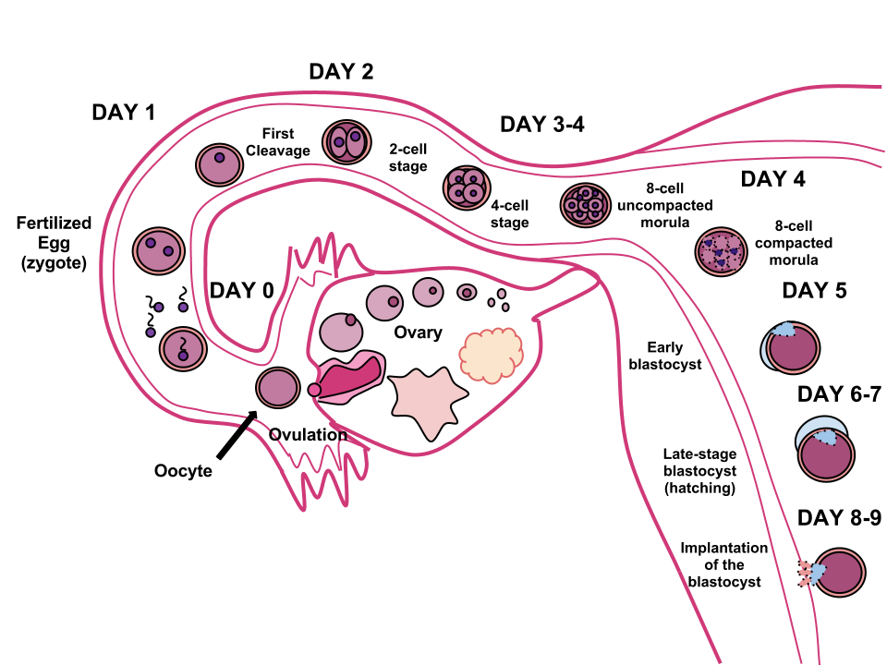

Fertilization

* Secondary oocyte **ovulated** from follicle (day 14 of the menstrual cycle) → travels into fallopian tube (widest part is **ampulla**) → sperm meets the secondary oocyte in the tube → sperm releases acrosomal enzymes to penetrate through the layers → sperm comes into direct contact with the oocyte’s cell membrane → forms **acrosomal apparatus** to penetrate the cell membrane → sperm’s **pronucleus** can enter the oocyte (once Meiosis II has completed) → **cortical reaction** (i.e. release of **calcium ions**) → depolarize the membrane of the ovum
  1. Prevents fertilization by multiple sperm cells
  2. Calcium increases the metabolic rate of the newly formed diploid zygote
* Twins

1. Dizygotic (or fraternal) twins
   1. Form from fertilization of **two different eggs** released during one ovulatory cycle by **two different sperm**
   2. Each zygote will implant in the uterine wall, and each develops its own placenta, chorion and amnion
   3. No more genetically similar than any other pair of siblings
2. Monozygotic (or identical) twins
   1. Form when a **single** zygote **splits into two**
   2. Genetic material is identical
   3. Incomplete division → conjoined twins
   4. Classified by the number of structures they share
      1. Monochorionic/ monoamniotic
      2. Monochorionic/ diamniotic
      3. Dichorionic/ diamniotic

Cleavage

* Zygote is **unicellular**
* Cleavage (rapid mitotic cell divisions) creates an **embryo** (multicellular) → more smaller cells but total size of the embryo remains unchanged
  + Increases nuclear-to-cytoplasmic ratio
  + Increases surface area-to-volume ratio

1. Indeterminate cleavage
   1. Results in cells that can still develop into complete organisms e.g. monozygotic twins
2. Determinate cleavage
   1. Results in cells with fates that are already determined
   2. Committed cell line

Blastulation

* After many divisions, a **morula** (a solid ball of cells) is formed → undergoes blastulation → **blastula** (hollow ball of cells with blastocoel) → **blastocyst** (mammalian blastula) consisting of **trophoblast** and **inner cell mass**

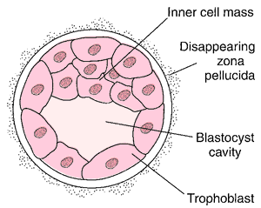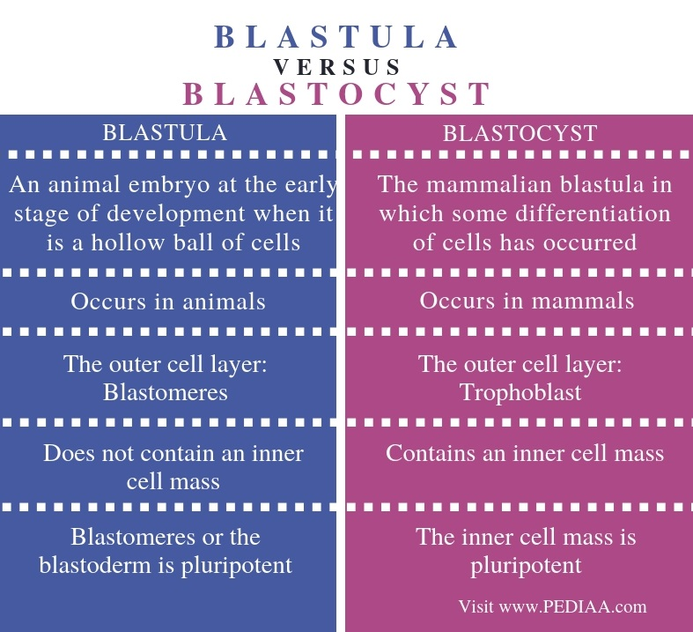

Implantation

* Trophoblast cells → chorion → fetal part of the placenta (a temporary organ)
  + Form the chorionic villi (fingerlike projections) develop into placenta → support maternal-fetal gas exchange
  + Chorion also forms an outer layer around amnion for more protection
  + The embryo (comes from inner cell mass) is connected to the placenta by the umbilical cord, which is made up of:
    - Two arteries: carry deoxygenated blood and waste to the placenta
    - Vein: carries freshly oxygenated blood rich with nutrients from the placenta to the embryo
* Yolk sac (formed by hypoblast cells)
  + Supports embryo until the placenta is functional
  + Early blood cell development
* Allantois
  + Involved in early fluid exchange between the embryo and the yolk sac
  + Surrounded by amnion
  + Remnants of allantois and yolk sac → umbilical cord
* Amnion
  + Thin, tough membrane filled with amniotic fluid → shock absorber during pregnancy

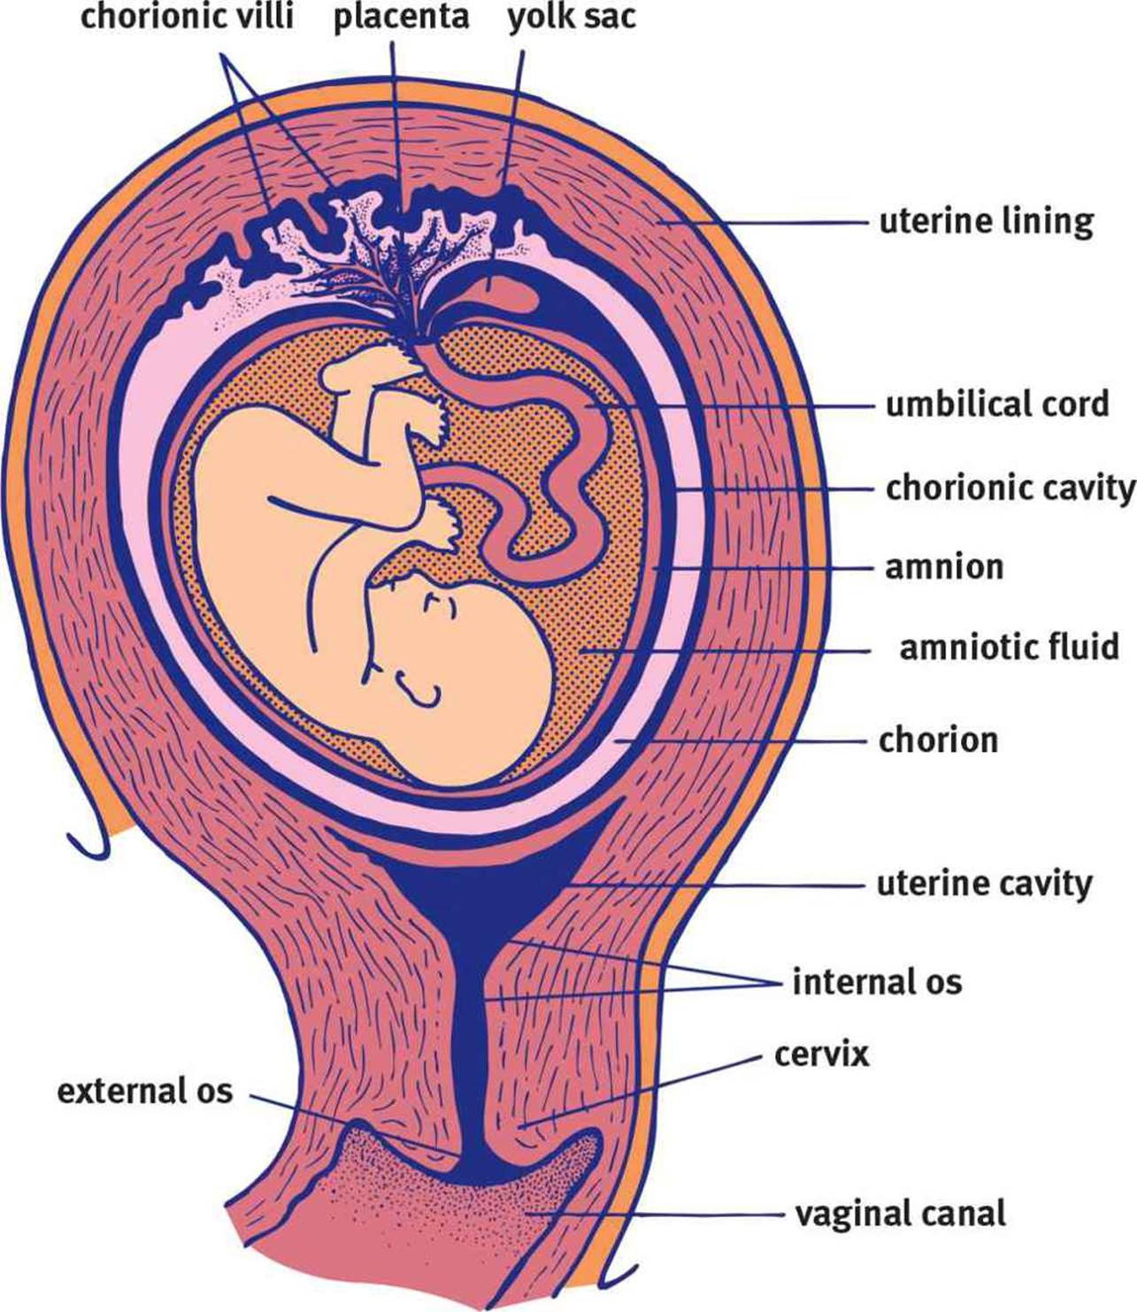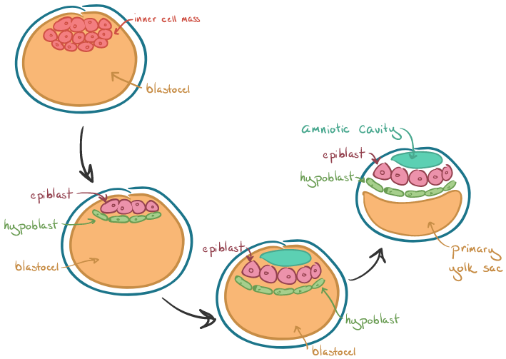

Gastrulation

* The generation of three distinct cell layers
* Blastula → Gastrula (it is like pushing the rubber from one side of the balloon)
* Archenteron (membrane invagination into blastocoel) → gut
* Opening of archenteron is called blastopore, which develops into:
  + Anus (in deuterostomes e.g. humans)
  + Mouth (in protostomes)

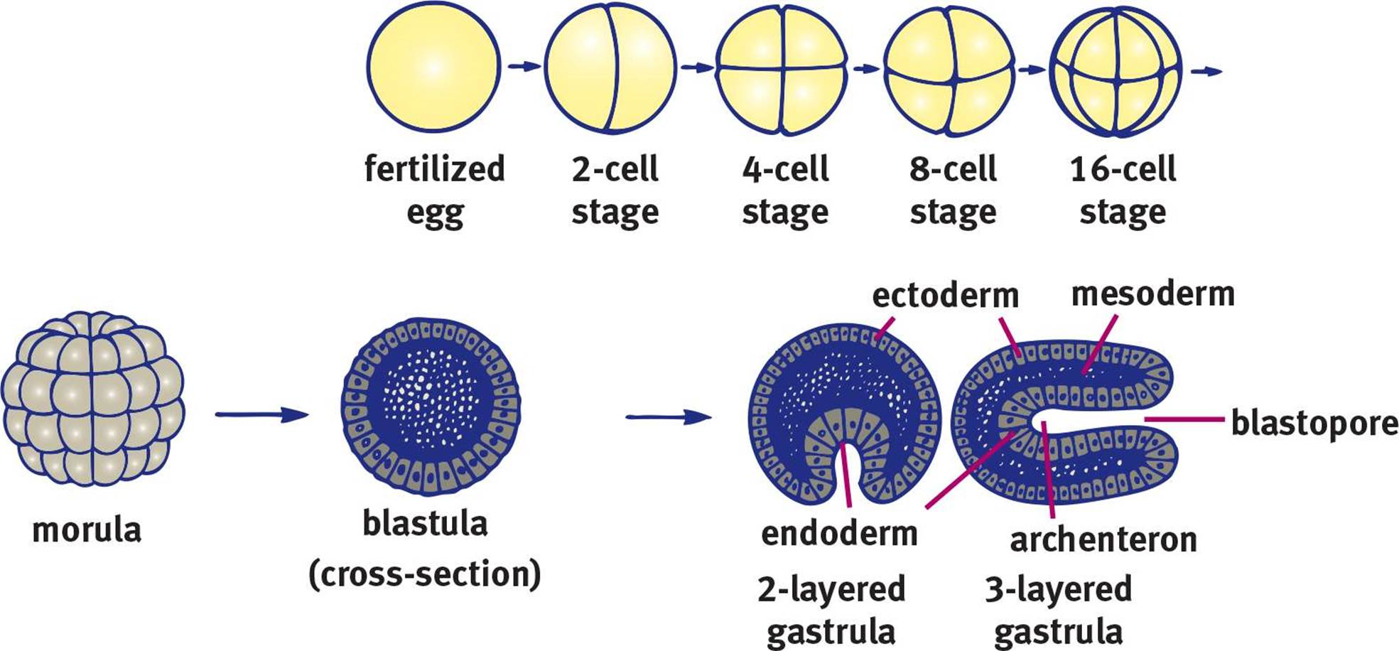

**Primary Germ Layers**

1. Ectoderm (outermost)
   1. Integument e.g. epidermis, hair, nails
   2. Lens of the eye, nervous system (including **adrenal medulla**), and inner ear
   3. Most of the lining of the mouth is derived from an invagination of the ectoderm
2. Mesoderm (middle)
   1. Musculoskeletal, circulatory, and most of the excretory systems
   2. Gonads, muscular and connective tissue layers of the digestive and respiratory systems, and **adrenal cortex**
3. Endoderm (innermost)
   1. Epithelial linings of the digestive and respiratory tracts, including the lungs
   2. Pancreas, thyroid, bladder, distal urinary tracts, and parts of the liver

Neurulation

* Neurulation (development of the nervous system) happens once the three germ layers are formed (gastrulation)
* Notochord (a rod of mesodermal cells) forms like a primitive spine (later part of vertebrae column) → induces **overlying ectodermal cells** to slide inward to form neural folds → neural groove → ultimately fuse into a neural tube **(CNS)** → **neural crest cells** (at the tip of each neural fold) migrate outward to form the **PNS**

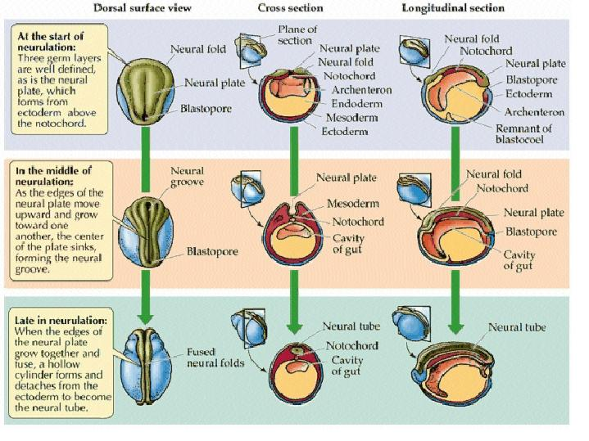

Problems in Early Development

* Teratogens = substances that interfere with development of developing embryo
* Maternal health e.g. diabetetic mothers with hyperglycemia, and maternal folic acid deficiency

**3.2 Mechanisms of Development**

Cell Specialization

* Specification → Determination → Differentiation

1. Specification
   1. **Reversibly** designated to a specific cell type
2. Determination
   1. **Irreversibly** designated to a specific lineage, but has not yet actually produced the products it needs to carry out the function of that cell type
   2. Pathways it may occur:
      1. Asymmetrical distribution of mRNA and protein between the daughter cells → presence of specific mRNA and protein molecules
      2. Secretion of specific molecules from nearby cells i.e. **morphogens**
3. Differentiation
   1. Process by which the cell undertakes changes that cause it to develop into the determined cell type
   2. **Stem cells** = cells that have not yet differentiated, OR which give rise to other cells that will differentiate
      1. Totipotency (cell type either in the fetus or placental structures)
      2. Pluripotency (any cell type except those found in placental structures)
      3. Multipotency (multiple types of cell within a particular group)

Cell-Cell Communication

* Inducer (growth factors, or the cell secreting the signal) induces the responder (responsive cell), which must be competent, to become a particular cell type

1. Autocrine: signals act on the **same** cell that secrete the signal in the first place
2. Paracrine: signals act on cells in the **local** area
3. Juxtacrine: signals do not involve diffusion, but **directly** stimulate the receptors of the **adjacent** cell
4. Endocrine: signals involve secreted **hormones** that travel through the **bloodstream** to a **distant** target tissue

Cell Migration, Cell Death, and Regeneration

* Induction and differentiation create different types of cells; however, these cells are not always in the right location to carry out their function
  + Sculpting of various anatomical structures sometimes requires cell death
  + Certain organs can recreate injured or surgically removed portions of tissue

1. Cell Migration
   1. Cells must be able to disconnect from adjacent structures and migrate to their anatomically correct location e.g. neural crest cells
2. Cell Death
   1. Apoptosis, or programmed cell death, occurs at various times in development e.g. webbed fingers becoming individual fingers
   2. Different from necrosis, which is cell death due to injury
3. Regeneration
   1. Ability of an organism to regrow certain parts of the body, varies from species to species
   2. Complete, or incomplete regeneration (humans usually exhibit this)
      1. Liver has high regenerative capacity, heart has little, kidneys have moderate

Senescence and Aging

* Biological aging

1. Cellular level
   1. Shortened telomeres (after each round of DNA synthesis) → cell is unable to replicate
   2. Somatic cells do not have telomerase like germ cells, fetal cells, and tumor cells → cannot reverse transcribe the ends of chromosomes → shortening telomeres → senescence
2. Organismal level
   1. Represents the changes in the body’s ability to respond to a changing environment

**3.3 Fetal Circulation**

1. Placenta
   1. Nutrient, gas, and waste products exchanges occur by **diffusion**. Note that Maternal blood and fetal blood **do not mix**!
   2. Immune protection → crossing of **antibodies** across the placental membrane
   3. Endocrine organ → produces **progesterone, estrogen, and hCG**
2. Fetal blood cells
   1. Contain fetal hemoglobin (**HbF**) → **greater affinity for oxygen**
3. Umbilical vessels
   1. Arteries: carry **deoxygenated** blood away from the fetus to the placenta
   2. Vein: carry **oxygenated** blood toward the fetus from the placenta

**Three shunts**

1. Foramen ovale (one-way valve)
   1. Shunts blood from the **right atrium** (coming from the inferior vena cava) **to the** **left atrium** (instead of the right ventricle) → pump blood through the aorta into systemic circulation directly
   2. This bypasses the **lungs**
   3. In adults, the left side has higher pressure than the right side, shutting the foramen ovale.
2. Ductus arteriosus
   1. Shunts leftover blood from the **pulmonary artery to the aorta**
   2. This bypasses the **lungs**
3. Ductus venosus
   1. Shunts blood from the **umbilical vein into the inferior vena cava**
   2. This bypasses the **liver**, which is still able to receive some blood supply from smaller hepatic arteries in the systemic circulation

**3.4 Gestation and Birth**

First Trimester

* Organogenesis → development of heart, eyes, gonads, limbs, liver, brain
* When the brain is fairly developed, the embryo becomes known as a **fetus**

Second Trimester

* Tremendous growth
* Movement begins (within the amniotic fluid)
* The face becomes distinctly human
* Digits elongate

Third Trimester

* Rapid growth and brain development continue
* Transfer of antibodies to the fetus

Birth

* Vaginal childbirth, or **parturition**, is accompanied by rhythmic contractions of uterine smooth muscle
  + Coordinated by **prostaglandins** and the peptide hormone **oxytocin**
* Three basic phases

1. Cervix thins out and the amniotic sac ruptures → water breaking
2. Strong uterine contractions
3. Placenta and umbilical cord are expelled → afterbirth